Name____________________
Class Period____________

UTAH HISTORY
UNIT 3 PACKET: PIONEERS & SETTLEMENT

Assignments:
- Pioneer Sequencing _______/5 points
- Pioneer Simulation _______/20 points
- Utah’s Settlement _______/10 points
- Clash of Cultures _______/10 points
- Settlers vs. N.A. Letter _______/20 points
- Put Yourself in Picture _______/5 points
- Transcontinental Video _______/10 points
- BONUS: Plan a Town _______/10 points
- BONUS: Find Your Way _______/10 points
TOTAL _______/80 points
Important Dates:
- TEST DAY-A Day: March 10th /B Day: March 11th
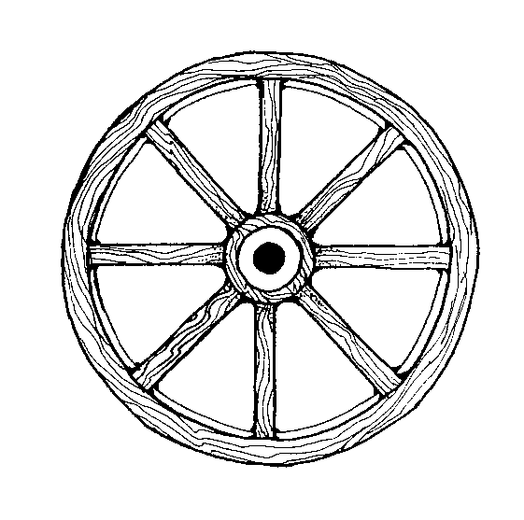
- PACKET DUE-on the day of the test

This packet is EXTREMELY important. It contains all assignments for the unit and will also serve as the study guide for the test. If you lose it, you will have to re-do the entire thing!)Bring it to class with you each day-------YOU WILL TURN THIS IN ON THE DAY OF THE TEST.

PIONEER SEQUENCING

DIRECTIONS: In history it’s essential to know the order in which events occur. Write the numbers 1-6 on the line next to the description, according to when it happened. Write a 1 for what happened 1st, and so on.

- Many Mormons gathered in Independence, Missouri. People from other states, Canada, and Great Britain joined the church.

- After leaving New York, the Mormons gathered in Kirkland, Ohio.

- More problems arose in Nauvoo. The Mormons moved to Council Bluffs, Iowa, and Winter Quarters, Nebraska.

- Missouri’s governor gave an extermination order that stated the Mormons would need to leave the state or be killed. The Mormons moved to Nauvoo, Illinois.

- On July 24, 1847, the first Mormons entered the Salt Lake Valley.

- Joseph Smith organized the Church of Jesus Christ of Latter-day Saints in Palmyra, New York.

_______/5 points
PIONEER SIMULATION
DIRECTIONS: You are going to experience life on the pioneer trail! Pay attention and fill in the spaces below as we go along the journeywest. If you are absent, you can access the PowerPoint online.
1. Please list and summarize the 6 reasons that caused conflict and misunderstanding between the Mormons and others in their communities:
- Reason #1_____________________________________________________________________
- Reason #2_____________________________________________________________________
- Reason #3_____________________________________________________________________
- Reason #4_____________________________________________________________________
- Reason #5_____________________________________________________________________
- Reason #6_____________________________________________________________________

2. Choice #1: Do you stay in Nauvoo or go west? Why? ________________________________________________________________________________________________________________________________________________________________________________

3. Supply List: Look at the supply list and decide on what you are going to take with you on your journey. Remember that your limit is 1800lbs minimum 2,500 lbs maximum! Make sure you have enough food to feed your family for the trip.
- How many days do you think you will be travelling? ___________________________________
- What should your priorities be? List 3 most important things to bring, remember you are never coming back and anything you leave behind will be taken by the mob.
- __________________________________________________________________________________
- __________________________________________________________________________________
- __________________________________________________________________________________
Item | Weight (lbs)
TOTAL | _________/2000
4. Explain why you brought 3 of the items on your list. At least one thoughtful sentence each.
- ________________________________________________________________________________________________________________________________________________________________

- ________________________________________________________________________________________________________________________________________________________________

- ________________________________________________________________________________________________________________________________________________________________

5. Choose 2 things you think you would have wanted to bring if there was space, why would it have been hard to leave these items behind? One thoughtful sentence each.
- ________________________________________________________________________________________________________________________________________________________________
- ________________________________________________________________________________________________________________________________________________________________

6. Test Fate #1: Explain what happened: ________________________________________________________

7. Food #1: You have travelled 300 miles it took about 21 days. Subtract 21 days worth of food from your supplies. How many pounds of food do you have left? __________________
8. How many days of travel can you make with your current food supplies? ____________

9. Choice #2: Do you stay in Winter Quarters or continue west? Why? __________________________________________________________________________________________________________________________________________________________________________________

10. Test Fate #2: Explain what happened: ______________________________________________________

11. Food #2: You have travelled 543 miles and it has taken 7.5 weeks or 54 days, subtract 54 days worth of food from your supplies. How many pounds of food do you have left? ________
How many days of travel can you make with your current food supplies? __________________

12. Choice #3: Do you follow the north or south side of the river? Why? _________________________________________________________________________________________

13. Test Fate #3: Explain what happened: ______________________________________________________

14. Food #3: You have travelled 373 miles and it has taken about 35 days. Subtract 35 days worth of food from your supplies. How many pounds of food do you have left? ____________ How many days of travel can you make with your current food supplies? _____________

15. Choice #4: Do you rest or push forward to Salt Lake City? Why? __________________________________________________________________________________________________________________________________________________________________________________

16. Test Fate #4: Explain what happened:_____________________________________________________

17. You’ve finally made it to the Salt Lake Valley!! Please reflect on this experience. What surprised you about the journey? What was unexpected? What kinds of things would you do differently if you had the chance? Make sure to answer all three questions. This should be at least 6 sentences!!! (3 points)
_________________________________________________________________________________________________________________________________________________________________________________________________________________________________________________________________________________________________________________________________________________________________________________________________________________________________________________________________________________________________________________________________________________________________________________________________________________________________________________________________________________________________________________________________________________________________________________________________________________________________
_______________________________________________________________________________________________________________________________________________________________________________________________________________________________________________________________________________________________________________________________________________________________________________________________________________________________________________________________________________________________________________________________________________________________________________________________________________________________________________
_______/20 points
UTAH’S SETTLEMENT
DIRECTIONS: Use the textbook to answer the following questions. Answer each question in 2-3 complete sentences. Page numbers are provided for your convenience.

1. How does physical location influence a settlement?

_____________________________________________________________________________________

_____________________________________________________________________________________

_____________________________________________________________________________________

2. Brigham Young “called” people to settle. What does that mean? Where did they go? What was the purpose? (Page #127) (Why was each “mission” specific in its purpose? – Why was the Cotton Mission THE Cotton Mission?)

_____________________________________________________________________________________

_____________________________________________________________________________________

_____________________________________________________________________________________

3. Read any part that interests you on one of the following pages: pages 124, 130-131, and 138-139. Then, after reading, tell me how that event or tradition affected those settling in Utah.

_____________________________________________________________________________________

_____________________________________________________________________________________

_____________________________________________________________________________________

4. Read about 2 of the settlements on pages 132-134. Tell me what you found interesting or what was unique about each settlement. (Tell me about landforms or physical features and how those things influenced the settlements.)

_____________________________________________________________________________________

_____________________________________________________________________________________

_____________________________________________________________________________________

_______/10 points
Clash of Cultures

THINKING QUESTION (Please write 3 complete sentences.)

Read each statement. Then say whether you think the statement is about Indians or Settlers. In the column marked Prediction, explain what the statement is talking about.
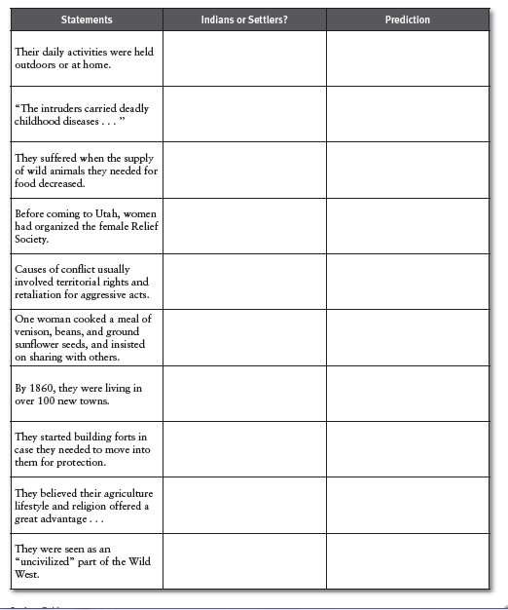

NATIVE AMERICANS SETTLERS

1. 1.

2.

2.

3.

Major Indian/White Conflicts:
There are several reasons why the settlers won most of the battles:
1) The Indians were never totally_________________.
2) The Indians were ___________________.
3) The Indians weapons were ____________________.

_______/10 points
Settlers vs. Native Americans Letter
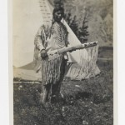
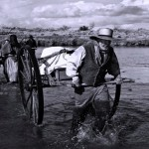
This land is your land…or is it my land? Now that you have had units on both Native Americans and Utah pioneers and have grown somewhat attached to these groups, what happens when there’s a conflict between them? You might have quite an opinion regarding this issue! This activity is a written correspondence between Native Americans and early Utah settlers that examines different points of view over the land-ownership conflict.

DIRECTIONS LETTER SIDE 1: You are a Native American, writing to a Utah settler. Using prior knowledge, write from a Native American’s point of view. Express your concerns about how your land is being taken over, and resources depleted, and share some ideas of how this conflict can be resolved. Sign the letter with an Indian name and state which Utah tribe you are from. Please fill the space below.
Dear Utah Settler,
_____________________________________________________________________________________________________________________________________________________________________________________________________________________________________________________________________________________________________________________________________________________________________________________________________________________________________________________________________________________________________________________________________________________________________________________________________________________________________________________________________________________________________________________________________________________________________________________________________________________________________________________________________________________________________________________________________________________________________________________________________
SIGNED_____________________________________
After the letters are written, they will be collected and redistributed at random until every student has someone else’s letter. Read the letter, and then turn it over and write a response as the settler.
DIRECTIONS LETTER SIDE 2: You are a Utah settler. After you have read the letter on the other side of this paper, write your response to the Native Americans. Write why you’ve come to Utah (Deseret), and why you need the land. Also include your own recommendations to solve this problem. Please fill the space below.
Dear _________________,
(use Native American’s name)
_____________________________________________________________________________________________________________________________________________________________________________________________________________________________________________________________________________________________________________________________________________________________________________________________________________________________________________________________________________________________________________________________________________________________________________________________________________________________________________________________________________________________________________________________________________________________________________________________________________________________________________________________________________________________________________________________________________________________________________________________________
SIGNED_____________________________________
(make up a settler name above) REAL STUDENT NAME___________________________________

Now pass this paper back to the original owner. Once you get your own paper back, read what they wrote to you. Record your reaction to what they said below:
FINAL REACTIONS (at least 5 complete sentences)
________________________________________________________________________________________________________________________________________________________________________________________________________________________________________________________________________________________________________________________________________________________________________________________________________
_______/20 points

Put Yourself In The Picture
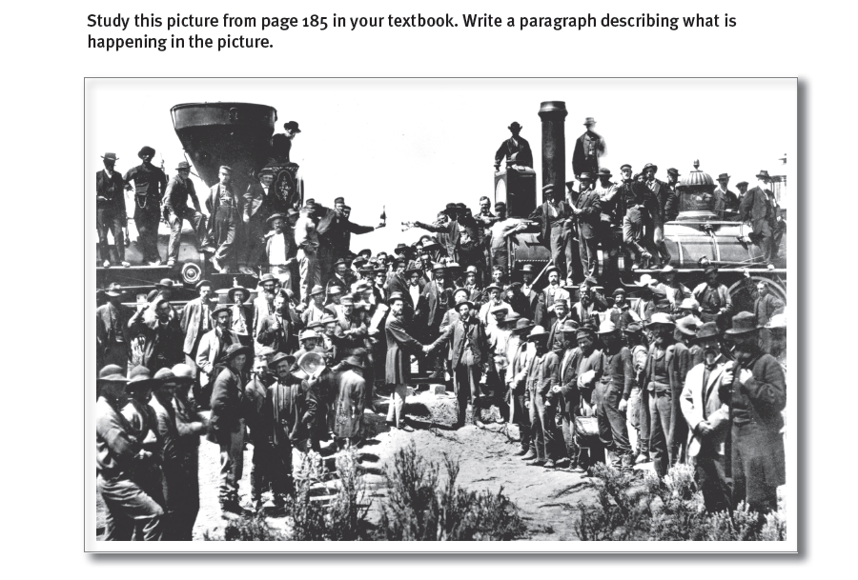
_______________________________________________________________________________________________________________________________________________________________________________________________________________________________________________________________________________________________________________________________________________________________________________________________________________________________________________________________________________________________________________________________________________________________________________________________________________________________________________________________________________________________________________________________________________________________________________________________________________________/5 points
Transcontinental Railroad Video Notes
Directions: Please answer the following questions in 2 COMPLETE and THOUGHTFUL sentences.

1. What are the names of the two companies involved with finishing the railroad?

2. Describe what happens to the railroad path as the tracks try to meet.

3. What is the bet made? What is the outcome?

4. What was the telegraph message sent from the celebration?

5. How did the railroad improve travel across the country?

Score: ___/10

