NAME__________________________
PERIOD_________________________

UNIT 5 PACKET: EARLY 1900’s & IMMIGRATION

Assignments
- Cities Video Notes __________/10 points
- Primary Source Analysis __________/10 points
- Immigration, Industry, and the American Dream __________/20 points
- Key People/Terms Chapter 12 & Bingo __________/10 points
- Utah Connections Notes __________/10 points

TOTAL __________/60 points

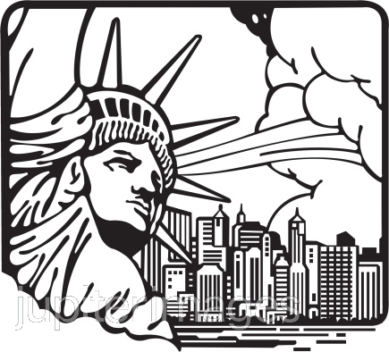

This packet is EXTREMELY important. It contains all assignments for the unit and will also serve as the study guide for the test. If you lose it, you will have to re-do the entire thing!)
Bring it to class with you each day-------YOU WILL TURN THIS IN ON THE DAY OF THE TEST.
CITIES: AMERICA THE STORY OF US VIDEO NOTES

Pre-Reading: Between 1880 and 1930, nearly 24 million new immigrants arrive in the United States. Many go to work building a new frontier: the modern city. The high cost of land in cities like New York and Chicago means the only way to build is up. A new kind of building, the skyscraper, is made possible by steel. Produced on a massive scale, steel production underpins the infrastructure of the modern city. This new urban frontier depends on the labor of rural migrants and newly arrived immigrant workers to grow. For many, the Statue of Liberty is their first sight of the New World and Ellis Island is the gateway to the American Dream. The lawless city offers opportunities for many and astronomical wealth for a few. Police chief Thomas Byrnes uses his harsh new innovation “the third degree,” to keep a lid on crime.

The millions flocking to urban areas of the U.S. often experience terrible conditions in disease-ridden tenements. Jacob Riis, photographer and reformer, brings their plight to the world with his groundbreaking photographs in the book “How the Other Half Lives.” Workers in new high-rise factories become urban martyrs in New York City’s Triangle Shirtwaist factory fire in March of 1911, as the city struggles to make these new buildings safe. Powered by steel and electricity, the city begins to be tamed and defined by mass transportation, stunning skylines, electric light...and the industrious
American spirit.

DIRECTIONS: As you watch the video, answer the questions below using 1-2 complete sentences.

1. What was the Bessemer steel converter? How did this invention shape U.S. history?

2. Why do you think so many everyday Americans contributed money to help build the Statue of Liberty?

3. What was the “rogues’ gallery” and what was its importance?

4. What were some of the other methods used to curb crime?

5. What was the key factor in Thomas Edison’s success in designing the light bulb?

6.What were some of the new things that were possible because of this invention?

7. Why do you think the Triangle Shirtwaist fire happened?

8. What were some of the results of this tragedy?

PRIMARY SOURCE ANALYSIS

Emma Lazarus wrote the following poem in 1883; today it is engraved on a plaque in the Statue of Liberty museum. Lazarus was an immigrant to the U.S. who became an advocate for other immigrants arriving on new shores for the first time. Read the poem and answer the questions in 2-3 sentences.

The New Colossus

Not like the brazen giant of Greek fame,
with conquering limbs astride from land to land;
here at our sea-washed, sunset gates shall stand
A mighty woman with a torch, whose flame
Is the imprisoned lightning, and her name
Mother of exiles. From her beacon-hand
Glows world-wide welcome; her mild eyes command
The air-bridged harbor that twin cities frame.
“Keep ancient lands, your storied pomp!” cries she
with silent lips. “Give me your tired, your poor,
Your huddled masses yearning to breathe free,
The wretched refuse of your teeming shore.
send these, the homeless, tempest-tost to me,
I lift my lamp beside the golden door!”

1. What do you think the phrase “world-wide welcome” means in relation to immigration in the U.S.?

2. What are some other phrases from this poem that are meaningful? Why?

3. Why is this poem considered an American classic today?
Immigration, Industry, and the American Dream

Overview: We will play an in-class game. You will be required to role-play representative figures from the immigration boom (1850-1920). Students will have scripted questions, answers, and clues to use while trying to solve the “Mystery of the Golden Key.” This game will provide an overview of period issues and attitudes.

DIRECTIONS: After the activity, answer the questions below in 3-4 thoughtful sentences.
1. Do you think that game was unfair to any of the characters?

2. Who in the game represented “industry” What did your character do?

3. Who represented “immigration”? Why did your characters come to this country and what was it like for them?

4. What is the American Dream? Who in the game achieved the American Dream?

5. Do you think people still believe in the American dream and do you think this dream is still possible?

6. Do people still immigrate to the United States, and do today’s immigrants face any of the same challenges faced by immigrants of the early 1900’s?
Key People and Words to Understand: Chapter 12
Directions: Turn to page 226 in your textbook. Choose 25 out of the 28 people or terms from the black bar on the left hand side of the page. Write a brief description or definition on the Lines Below.
Word/Person | Description
1.
2.
3.
4.
5.
6.
7.
8.
9.
10.
11.
12.
13.
14.
15.
16.
17.
18.
19.
20.
21.
22.
23.
24.
25.

BINGO
Choose a space for each of the words on the other side of the page. Only write the word, not the definition. Listen for the symbol to mark each space for the round.
FREE
UTAH CONNECTIONS NOTES

